# 

By Jason Krieg - 2019

# Game manual

## About

Marten’s Ploy is a 2D, top down view, multiplayer puzzle game inspired by Portal 2’s co-operative campaign. The puzzles are designed in a way that requires two players to progress, so you must work together to avert Marten’s Ploy and return to your lemon tree. But are you really a lemon, or are you a yellow robot on a wheel? No one knows, not even me…

and who is Marten?

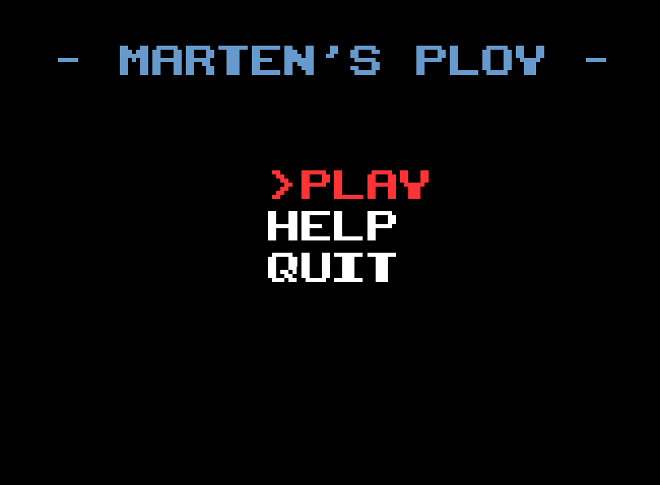

## Starting the game, playing 2 games on one computer

It is possible to have the game running in 2 separate windows on the same machine. One window will run the server and the second window can connect to that server by typing *“localhost”* or *“127.0.0.1”* when prompted for the host’s IP address.

## Starting a game over a network

To start a game, one player needs to run the server and the other player then connects to that server. To start a server, press play and a popup will appear asking if you would like to host the server:

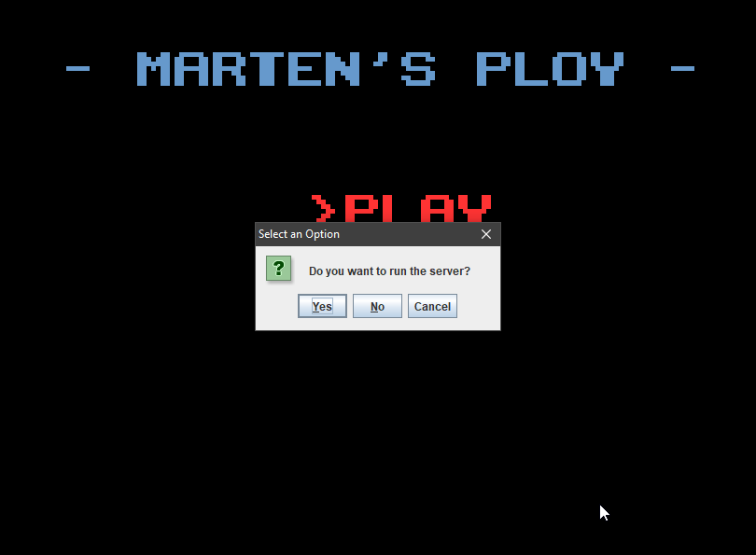

Select yes and then enter in a username and you will have started your server, now your co-op partner can connect. To connect to the host, select no when asked to run the server and then enter the public IP address of the host’s PC (Just google my IP if you are unsure).

If both computers are on the same network, then you should have no issues connecting to each other. However, if you are connecting across the internet then you will probably run into some issues. This is because your router will not be allowing access to your server from an unidentified application or location.

To fix this, you will need to go into your router settings and add a new port forwarding/sharing rule – this is different depending on your router. Here is an example using a FRITZ!Box 7560 router:

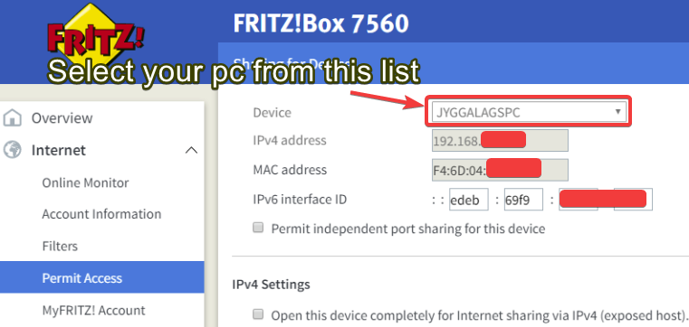

At the bottom of the page, click on new sharing and you should see a screen like this:

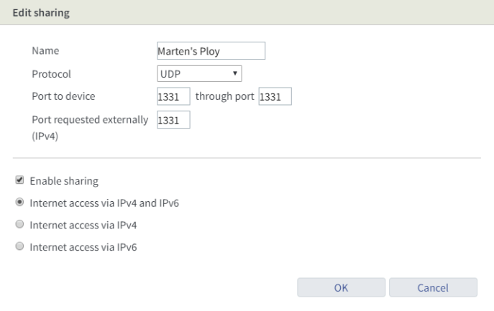

Give the rule any name and enter port 1331 – I could have added functionality for the user to choose a port themselves in the game but I didn’t have time so it is hard coded, this is the port you will need to use.

Now start a server and give your co-op buddy the IP address listed here: <http://whatismyip.host/> This will give you your public ipv4 address. With any luck you should now be connected together.

With any more luck your game won’t be as laggy as the game I played with my friend in Waikanae! <https://www.youtube.com/watch?v=FSxavkJKjwE&feature=youtu.be>

## Controls

The controls for Martens Ploy are very simple, move with the arrow keys or wasd, and interact with things with the e button. Pressing the escape key will pause the game. The controls are also found in the help menu:

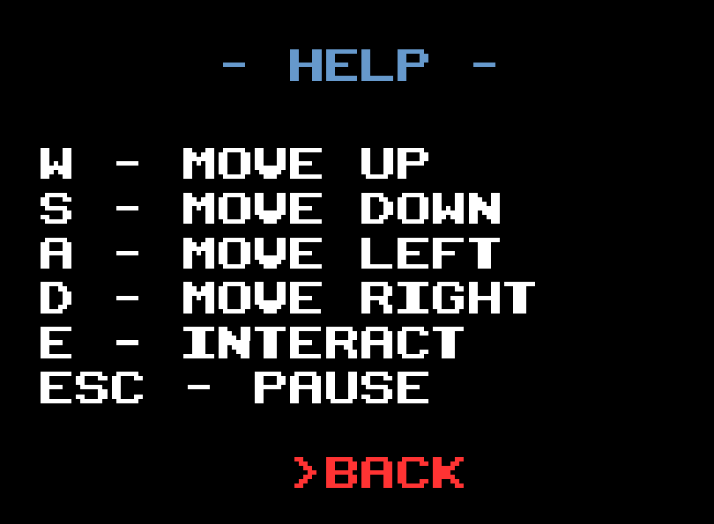

## Interactions

In Marten’s Ploy, you will solve puzzles by interacting with certain things in the world such as:

* Pressure plates:

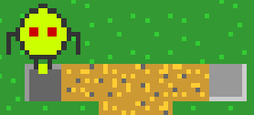

* Buttons

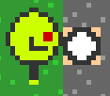

* Rocks

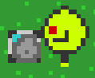

* Open doors and closed doors

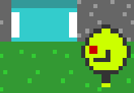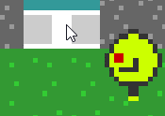

* And you can even swim!



## Testing

For testing purposes, I commented out the code for 2 buttons in the game as it is impossible to press two buttons at the same time on one machine.

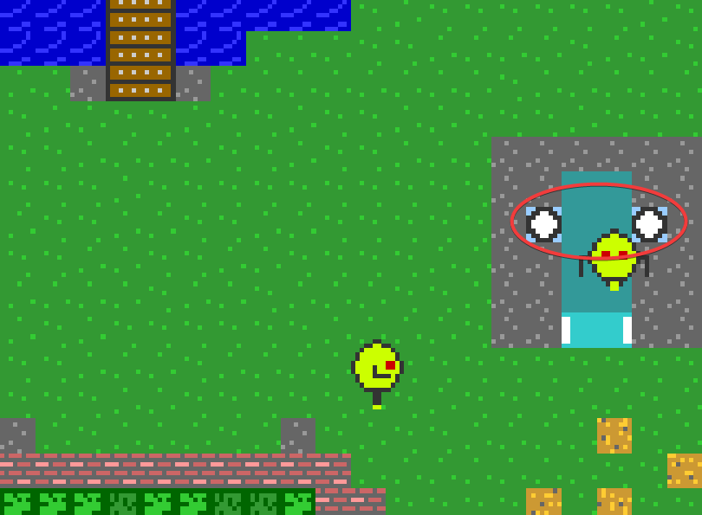

In the above case each player presses one of the buttons each at the same time. For testing purposes I commented out the code that instantiates the button on the right. The same goes for the image below:

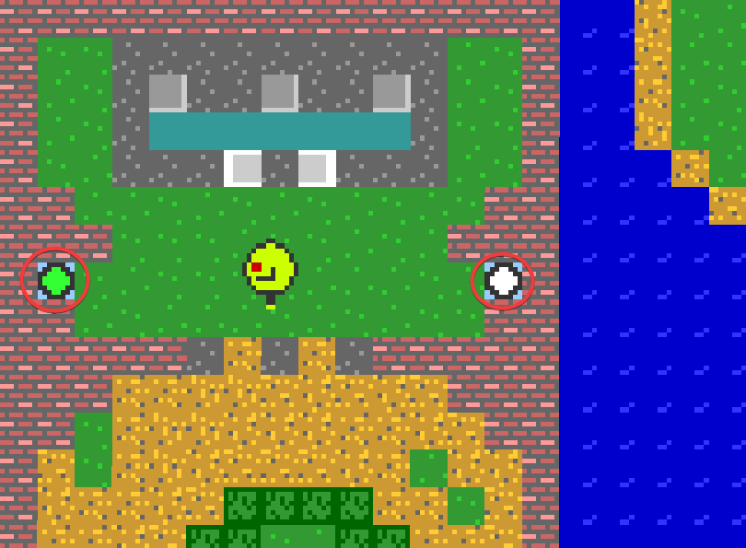

I ran a coverage test of a normal 2-person full run through of the game, here are the results:

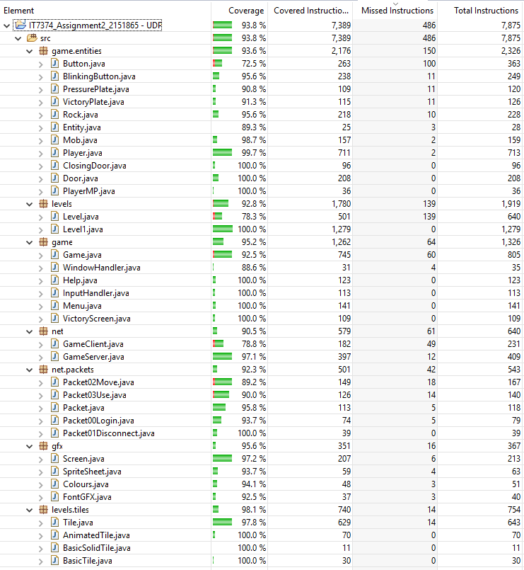

I also uploaded a full run-through of the game to YouTube as proof that it all works (or if you can’t be bothered to figure out the puzzles on your own: <https://www.youtube.com/watch?v=X-P8zv6ZDlA&feature=youtu.be>

## Music

The music was written by my good friend Josh Brown.

## Known bugs

* If both players use the same name, then they will both control the same player.
* The door at the bottom of the map at the exit of the hedge maze sometimes will not stay open long enough for the player to pass through it – I tried adjusting it by 1 second and it ended up making it so that the player pressing the button could also make it through in time before the door closes again so I set it back. – The door eventually works if you keep pressing the button, you might even get it first try.
* If you are holding a movement or the interact button and then switch to another window, the character will keep performing that action until the button is pressed again.
* Games can sometimes fall slightly out of sync – this only affects blinking buttons across clients meaning that they will be green on one client and not green on the other, this will result in a door opening for the player whose client has a green button but not for the other player. – Fix this by holding down the interact button.
* Rocks can also become out of sync across clients – one client will think that their player is holding the rock while the other client will not – Fix this by respawning the rock with the button which spawns it.
* A player can pick up 2 rocks at once if they are in the same place, this will make the game impossible to complete – Fix this by respawning one of the rocks with the button which spawns it.
* It is possible for more than 2 players to connect to a server.
* If more than 2 players are connected to a server, the second player will only be able to see the first player standing still where they were when the third player joined, and will not be able to see anyone else. However, the first, and any subsequent players from the 3rd onwards are able to move normally and can see each other. (Tested up to 5 different players on a localhost).